Questionnaire: TRACOpress Lifting Bags for Special Requirement 
ECOcushions – VTRcushions – VULCANcushions – Liftings bags CLT “Heavy Duty” – Special design TRACOpress-The Power of Air

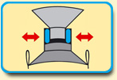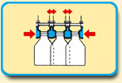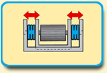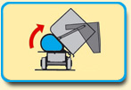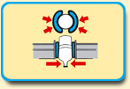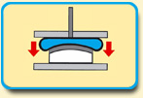

Order: ..... Inquiry: .....

Sender’s address (Stamp):

………………………………………………………………………………………………………..…….

Person in charge: …………………………….. Phone: ................................... Fax: ................................

Signature: Date: ……………...………...

...................................................................

Qty.: ............. pieces Dimensions in mm (thickness x width x length): .............................................

Application: …………………………………................................................................................

Medium (air, water, gas): …………………... Material in contact: ………..…………………

Ambient temperature: .......... °C, Contact temperature: ......... °C
(Standard range: - 20° up to +60 °C)

The cushions have to be resistant against: ...................................................................................

Working pressure/bar: ………Working stroke in mm: ……… Lifting power in kN/t: ….…….

Period of stroke: ............ sec. Nos. of strokes: ............. hour Strokes per year: .................

Positions of valve sockets, please specify by drawing:

Centered: ...... Off centered: …… Edge: ……. Corner: ……

Size/length, male or female: G 1/8“ x ….. G ¼“ x ….. G 3/8“ x ….. G ½“ x ….. Others: …...

Remarks/special requests/surrounding/sketch:

TRACO Export-Import GmbH - Am Wetzelshaus 22 - D-40883 Ratingen - Phone: +49 2102 9699-75 Fax: -89 - info@traco-online.de - www.traco-online.de
VAT.-ID: DE 121634087 – Location: Ratingen – Court: Amtsgericht Düsseldorf HRB 43102 – Gen.-Mgr.: Dipl.-BW Wolfgang Benke

Flexible Pneumatics out of one source - Since 1979 quality and reliability ☺

